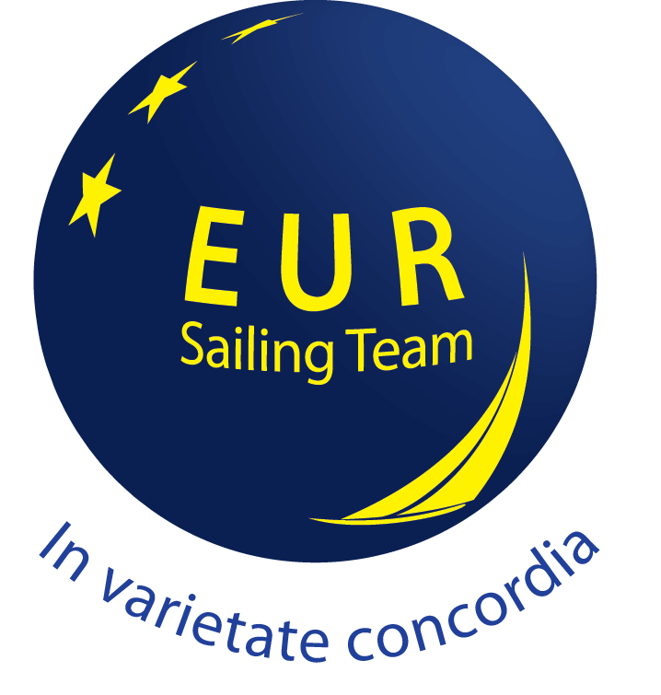
OPEN NORTH SEA CHAMPIONSHIP 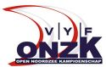
The General Sailing Instructions the Notice of Race (NoR) and the Local Sailing instructions for the regattas are not yet available.
If you like to have more information about the ONZK circuit, contact us by mail: EUR.Sailing.Team@gmail.com

