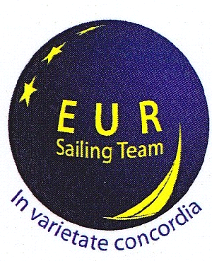 | NEW BANK ACCOUNT!  IBAN BE98 8601 1884 5893 |   EUR Sailing Team asbl is affiliated to the Vlaamse Yachting Federatie
EUR Sailing Team asbl - Membership for 2015
I the undersigned:
Surname : | First Name :
Date of Birth (dd/mm/yyyy) : | Languages spoken : EN FR Mother tongue :
Would like to apply to become an associate member (“membre adherent”) of EUR Sailing Team asbl

Commission | Private sector
Council
E.P.
EESC
other :
Private address  Street, No: | Private Tel. No.:
Post Code : Locality: | Mobile Tel. No. :
e-mail address :

I undertake to comply with the statute and internal rules of the EUR Sailing Team asbl of which I am also aware. I exonerate the EUR Sailing Team, the organisers and the skippers of all responsibility for any damage or harm which may incur to me or to my personal belongings during any activity in which I participate.

I have transferred on EUR Sailing Team bank account IBAN BE98 8601 1884 5893
- the support Membership fee of 20€ (for non-sailing members)
- the annual membership fee of 50€ including the compulsory sailing insurance provided by the VYF
- the family membership fee of 40€ and I have added _____x 15€ p. pers. for the sailing insurance
Surname: First name: Date of birth:
2) ……………………. ……………………………. …………………………..
3) …………………….. …………………………….. …………………………...
4) …………………….. …………………………….. …………………………...

If you have any question on membership or activities, please do email to EUR.Sailing.Team@gmail.com, we will call your back asap.

SIGNATURE: …………………………………… DATE: / /

* Please send your application form, signed and dated to: EUR.Sailing.Team@gmail.com

Important : Your membership request will be processed on receipt of the signed and dated application form by the Secretariat and upon transfer of the membership fee into the EUR Sailing Team ASBL bank account IBAN BE98 8601 1884 5893, BIC: SPAABE22. Then it will be transmitted to the Board Committee for validation. In case your application is not accepted by the Committee, the membership will be reimbursed accordingly. Please advise the Secretariat of any changes in your mail address. Thanks

Rue Haute 79, B-1000 Brussels

WWW.EUR-SAILINGTEAM.EU

